**Image Classification on Foliar Disease Images in Apple Trees**

**SEIS -764-01 – Artificial Intelligence**

**May 07, 2023**

**Team members:**

**Carl Dekpor**

**Lihu De**

**Moses Nenpa**

**Olanrewaju Ajewole**

Table of Contents

Section 1: Overview 3

Section 2: Motivation 3

Section 3: Tools and approach 3

Section 4: Dataset Overview 3

Description of data source and web links: 3

Description: 3

Data Pre-Processing: 5

Section 5: Models 5

Model 1: (Traditional CNN model) 6

Classification report of the CNN model: 6

Confusion matrix: 7

ROC Curves 7

Training and validation accuracy/ loss 8

Model 2:(Xception transfer model) 9

Classification report of the CNN model: 9

Confusion matrix: 10

ROC Curves 10

Training and validation accuracy/ loss 11

Model 3: ResNet50 12

Classification report: 12

Confusion matrix: 13

ROC Curves: 13

Training and validation accuracy/ loss: 14

Model(s) Performance Comparison 15

Section 5: User Manual 15

Guidelines: 15

Package description: 15

# 

# 

# 

# 

# Section 1: Overview

Apples are one of the most important temperate fruit crops in the world and are mostly affected by the Foliar (leaf) diseases which pose a major threat to the overall productivity and quality of apple orchards.

The conventional approach to disease diagnosis in apple orchards is based on manual scouting by humans, which is time-consuming and expensive.

The goal of our project is to build deep learning models that can classify images of plants as healthy or scab and compare their performances.

# Section 2: Motivation

The reason for choosing this project is to gain real-world experiences in the application of some topics learned in class.

The project also has practical applications in agriculture, as early detection of plant diseases can help reduce crop losses and improve food security.

From this project we will be able to compare how different models perform on the image classification of plant disease?

# Section 3: Tools and approach

We signed up to Google colab pro for faster GPU and coding was done with Python.

# Section 4: Dataset Overview

## Description of data source and web links:

<https://www.kaggle.com/competitions/plant-pathology-2021-fgvc8/overview>

Number of records & number of attributes with description of each attribute.

## Description:

The dataset was acquired from Kaggle (Plant pathology 2021).It originally contains approximately “23,000 high-quality RGB images of apple foliar diseases, including a large expert-annotated disease dataset”(Kaggle). We trimmed the datasets for our 2 labels (Healthy and Scab)

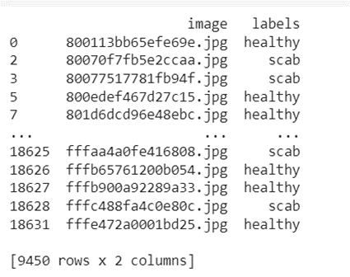

Figure 1. - snapshot of trimmed dataset

# 

Figure 2. Data distribution of the datasets between healthy and scab

## Data Pre-Processing:

The only augmentation applied was resizing the images in the dataset to 256 x 256 to maintain uniformity

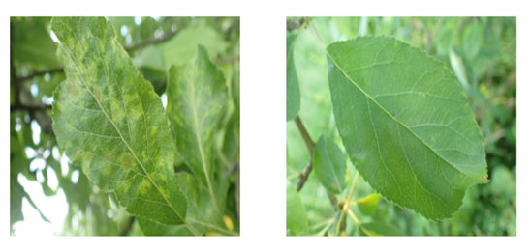

Figure 3. - Image of scab leaves

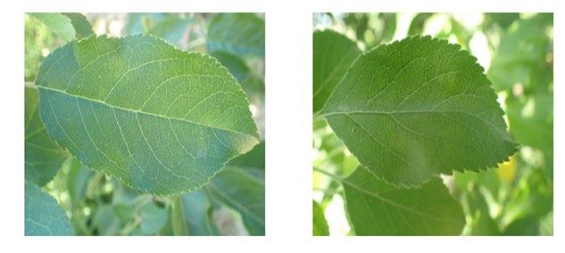

Figure 4. - Image of Healthy leaves

# Section 5: Models

The various models used for the project is as below:

Using a traditional CNN model

Xception transfer model

ResNet50 transfer model

We first performed a slip of 70/30 on the dataset for the training and test data and also used a random state of 123 for all the models.

## Model 1: (Traditional CNN model)

For building the traditional CNN model a filter of 32-64-64-128 was used with a ReLu activation function and a softmax function was used for the dense layer. An epoch of 10 was also used to train our model.

Below is the architecture for the CNN model

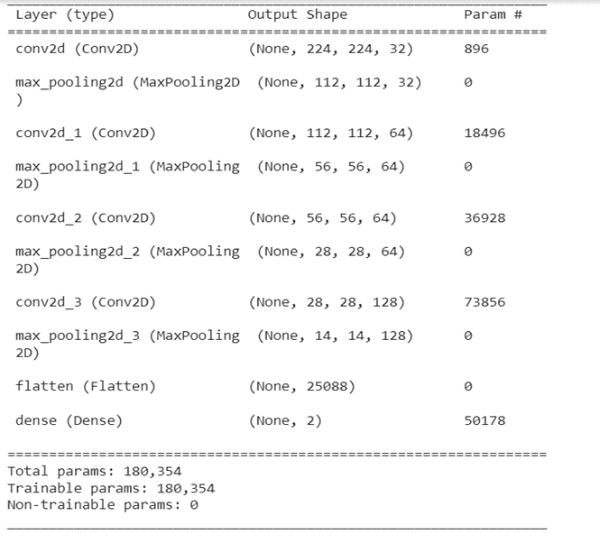

### Classification report of the CNN model:

From the classification report the precision for healthy leaves is 67% and that for scab is 74% which indicates the models ability to classify both healthy and scab leaves correctly.

The model was able to predict recall values of 77% for healthy leaves and 64% for scab leaves. Which indicates the model's ability to actually predict the correct positive value.

The model has an accuracy of 70% which indicates the models ability to find the portion of correctly classified values.

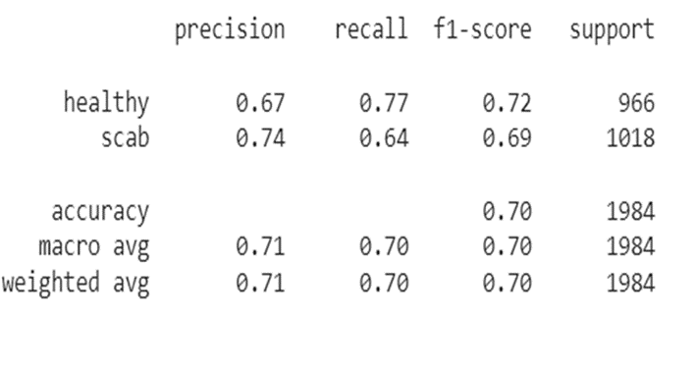

### Confusion matrix:

Confusion matrix helps identify the correct predictions of a model for different individual classes as well as the errors. The confusion matrix below shows that the CNN model was able to predict 740 healthy leaves correctly for the true positives(TP). 226 scab leaves were falsely predicted as healthy leaves by the model representing the false negative(FP). 363 healthy leaves were falsely predicted as scabs by the model representing false negative(FN). 655 scab leaves were correctly predicted as scabs representing the true negative(TN).

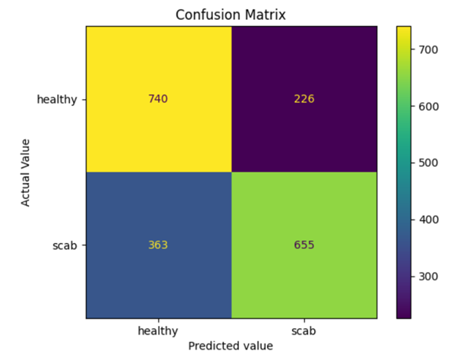

### ROC Curves

The more the ROC curve hugs the left corner of the plot the better. To quantify this we can calculate the AUC(area under the curve), from the figure below the area is 0.79.

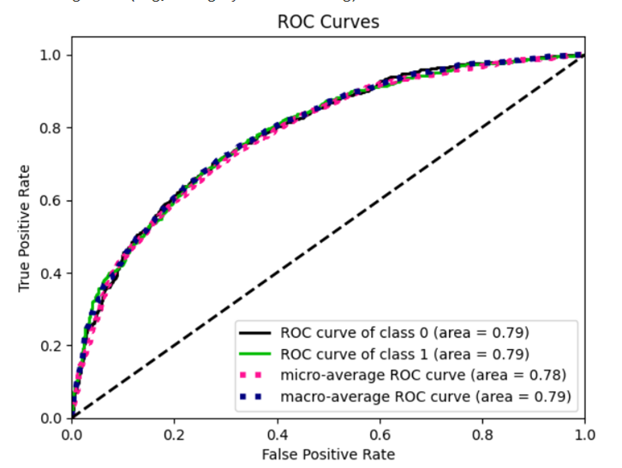

### Training and validation accuracy/ loss

The training accuracy started pretty high at about 75% which gradually increased with increase in the number of epochs, same with the validation accuracy increasing steadily from an initial accuracy of about 80% with no over-fitting issues. The training loss however decreased with increase in the number of epochs. The validation loss remained fairly constant after the initial decrease.

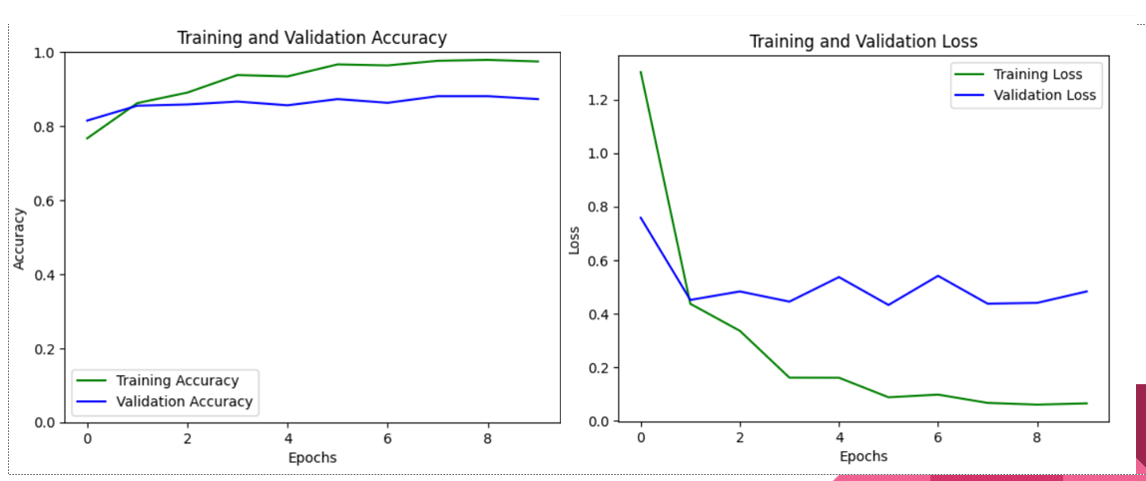

## Model 2:(Xception transfer model)

For the Xception transfer model a softmax activation function was used for the dense layer. An epoch of 10 was also used to train our model.

Below is the architecture for the CNN model

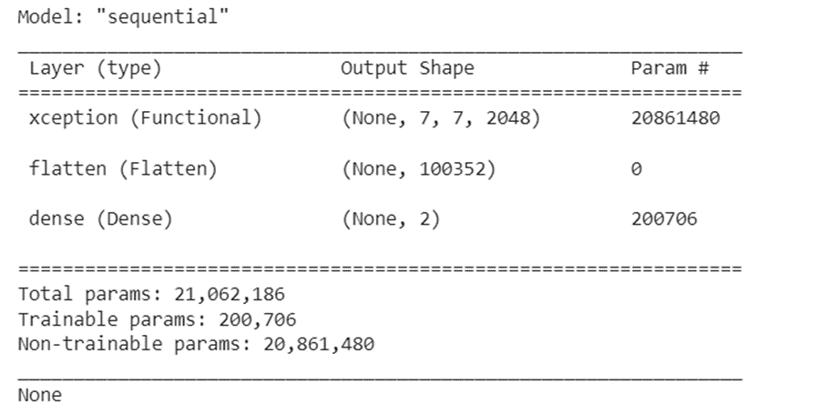

### Classification report of the CNN model:

From the classification report the precision for healthy leaves is 85% and that for scab is 86% which indicates the models ability to classify both healthy and scab leaves correctly.

The model was able to predict recall values of 85% for healthy leaves and 86% for scab leaves. Which indicates the model's ability to actually predict the correct positive value.

The model has an accuracy of 85% which indicates the models ability to find the portion of correctly classified values.

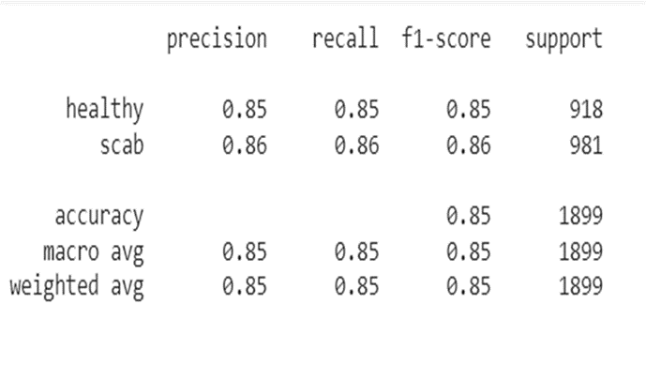

### Confusion matrix:

Confusion matrix helps identify the correct predictions of a model for different individual classes as well as the errors. The confusion matrix below shows that the Xception model was able to predict 781 healthy leaves correctly for the true positives(TP). 137 scab leaves were falsely predicted as healthy leaves by the model representing the false negative(FP). 140 healthy leaves were falsely predicted as scabs by the model representing false negative(FN). 841 scab leaves were correctly predicted as scabs representing the true negative(TN).

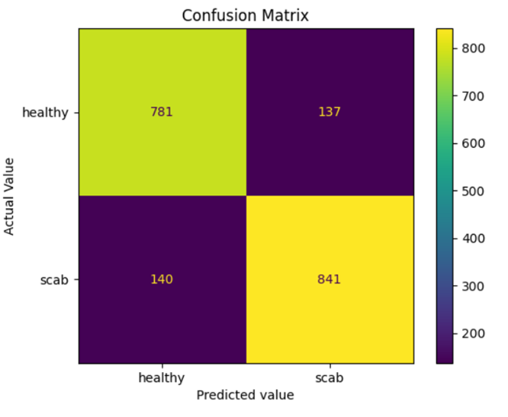

### ROC Curves

The more the ROC curve hugs the left corner of the plot the better. To quantify this we can calculate the AUC(area under the curve), from the figure below the area is 0.94.

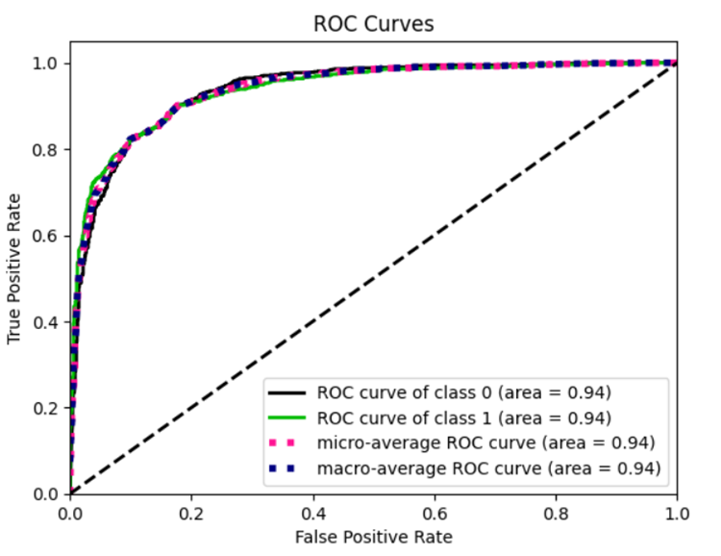

### Training and validation accuracy/ loss

The training accuracy started high at about 75% which gradually increased with increase in the number of epochs, same with the validation accuracy with no over-fitting issues. The training loss however decreased with increase in the number of epochs. The validation loss also decreased gradually but increased sharply on the 8th epoch.

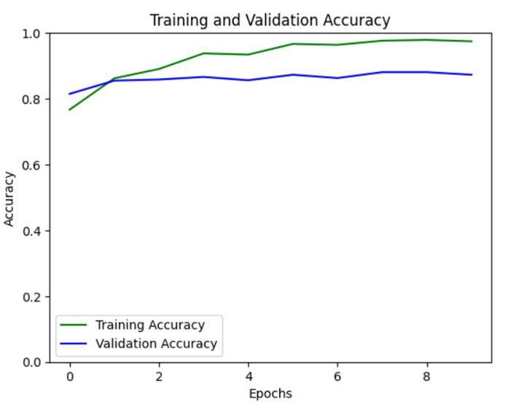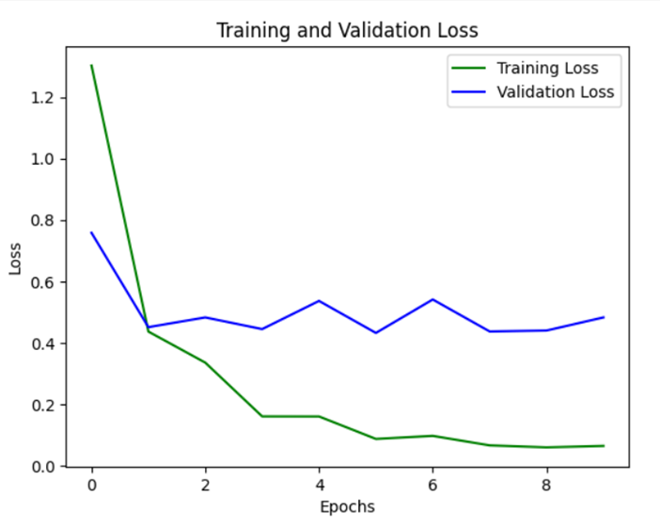

## Model 3: ResNet50

**ResNet50 architecture**

ResNet-50 is a convolutional neural network that is 50 layers deep.

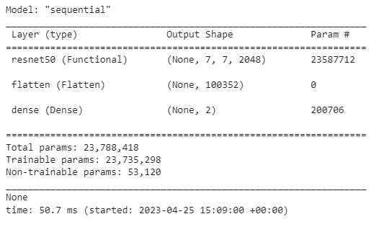

### Classification report:

From the classification report the precision for healthy leaves is 64% and that for scab is 99% which indicates the models ability to classify both healthy and scab leaves correctly. The model has an accuracy of 72% which indicates the models ability to find the portion of correctly classified values. The model was able to predict recall values of 100% for healthy leaves and 46% for scab leaves.

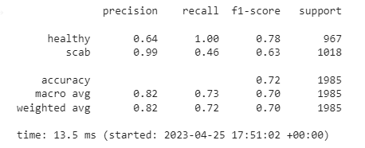

### Confusion matrix:

There are 964 healthy leaves correctly identified as healthy leaves, but 550 incorrectly identified as scab. 468 out of 471 scabs are correctly identified and only 3 incorrectly identified as healthy.

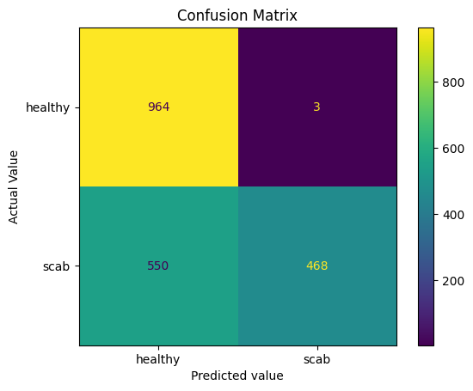

### ROC Curves:

The AUC for the class 0 ROC curve is greater than the AUC for the class 1 ROC curve, suggesting that the class 0 ROC is better. So, the model resnet50 on predicting healthy leaves is better than predicting scab leaves.

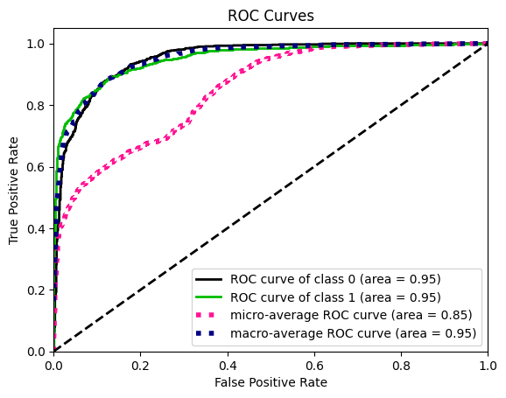

### Training and validation accuracy/ loss:

Training loss is lower than validation loss. The training accuracy started high at about 72% which gradually increased with increase in the number of epochs, same with the validation accuracy with no over-fitting issues. This tells me that the model is working well with the training data, but not as much as validation.

|  |  |
| --- | --- |

## Model(s) Performance Comparison

| **Model** | **F1** | **Precision** | **Recall** | **Accuracy** |
| --- | --- | --- | --- | --- |
| **CNN** | 0.72 Healthy 0.69 Scab | 0.67 Healthy 0.74 Scab | 0.77 Healthy 0.64 Scab | 0.70 |
| **Resnet** | 0.78 Healthy 0.63 Scab | 0.64 Healthy  0.99 Scab | 1.00 Healthy  0.46 Scab | 0.72 |
| **Xception** | 0.85 Healthy 0.86 Scab | 0.85 Healthy 0.86 Scab | 0.85 Healthy 0.86 Scab | 0.85 |

Description:

This is the model comparison of different architectures trained in the work. The trained network of Xception performs the best on the training set in terms of the accuracy metric. Since we want to identify healthy leaves, the focus is precision. In other words, the healthy leaves were identified correctly. Therefore, Xception is the best model on this matter.

# Section 5: User Manual

## Guidelines:

The program is based on the Python programming language with Google Colaboratory as IDE.

The data is extracted from Plant Pathology 2021 - FGVC8. (https://www.kaggle.com/competitions/plant-pathology-2021-fgvc8/overview)

## Package description:

| train.csv | the training set metadata. |
| --- | --- |
| sample_submission.csv | A sample submission file in the correct format. |
| train_images | The training set images. |
| test_images | The test set images. |

Steps:

1. We suggest you execute this code by using Google Colaboratory (Colab), which is a free cloud-based Jupyter Notebook environment.